Project Title: Industrial Predictive Modeling for Telco Customer Churn
Problem Definition: > The objective of this project is to develop a predictive model using the Telco Customer Churn dataset to determine if a customer will cancel their service (Churn) based on features such as Tenure, Monthly Charges, Contract Type, and Payment Method. To consider the project successful, the final model must achieve a minimum Accuracy of 85% and an F1-score of 0.80. This project follows Path 2 (Industrial Machine Learning) and will compare classical algorithms like Random Forest and XGBoost to identify the most efficient solution for reducing business attrition.
Detail | Value
Dataset Source | Telco Customer Churn (Industrial Dataset)
Number of Samples | 7,043
Number of Features | 20 (Input) + 1 (Target)
Target Variable | Churn (Yes/No)
EDA & Data Visualization:
Chart 1: Distribution of Target Variable (The count plot showing Churn vs. No Churn).
Chart 2: Correlation Matrix (The heatmap of numerical features).
Chart 3: Distribution of Monthly Charges (The histogram with the KDE line).
Chart 4: Monthly Charges vs. Churn (The box plot).
Chart 5: Churn by Contract Type (The bar chart comparing Month-to-month, One year, etc.).
Chart 6: Churn by Payment Method (The bar chart showing electronic check, mailed check, etc.).

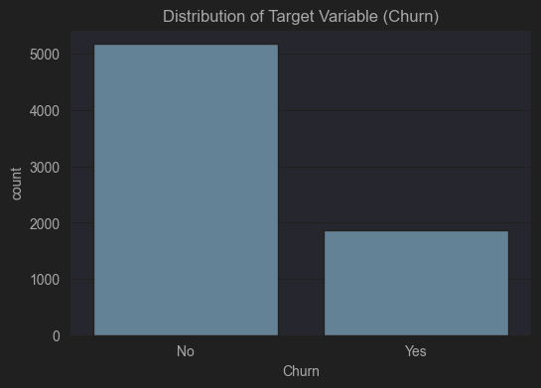

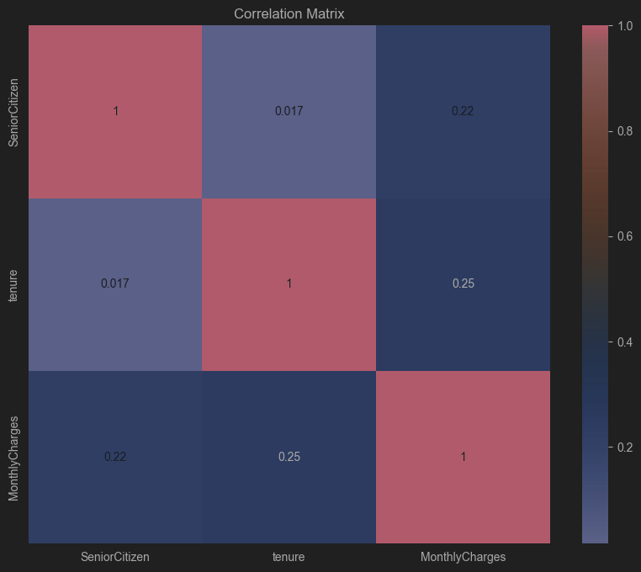
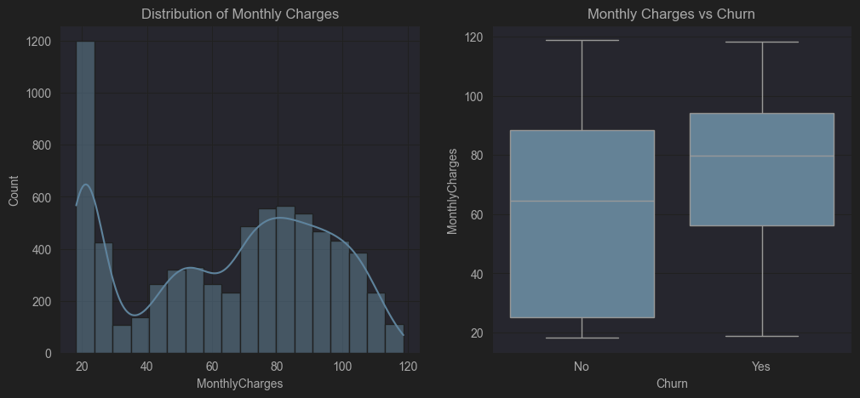
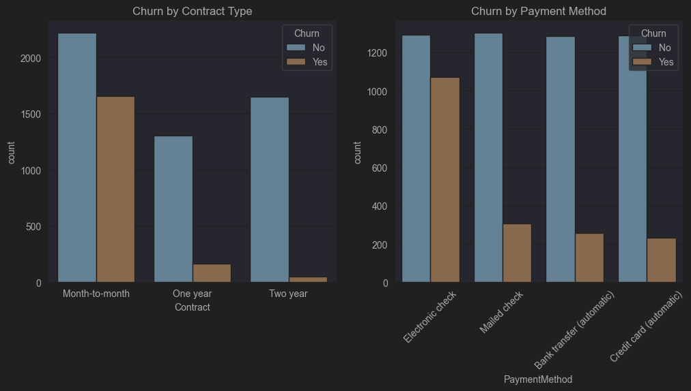
3.1 Data Cleaning and Feature Engineering
To prepare the raw Telco dataset for machine learning, the following steps were implemented in the preprocessing pipeline:
- Handling Numeric Conversion: The TotalCharges column was converted from an object (string) type to a numerical float type. Rows with empty strings were treated as null values and filled using the median of the column to maintain data integrity.
- Feature Removal: The customerID column was dropped as it serves as a unique identifier with no predictive power for customer churn.
- Categorical Encoding: Since the majority of features were categorical (text-based), One-Hot Encoding was applied. This transformed variables such as Contract and PaymentMethod into binary columns, allowing the classical ML algorithms to process them.
- Target Encoding: The target variable Churn was encoded into a binary format (0 for "No", 1 for "Yes") using a Label Encoder.
3.2 Feature Scaling and Data Splitting
- Standardization: To prevent features with larger ranges (like TotalCharges) from dominating the model, StandardScaler was applied to all numerical columns (tenure, MonthlyCharges, TotalCharges). This ensures all features are centered around a mean of 0 with a standard deviation of 1.
- Industrial Data Split: The dataset was partitioned into a 70% Training set and a 30% Testing set. Stratified sampling was used to ensure the distribution of "Churn" vs. "No Churn" remains consistent across both sets, which is critical for handling label imbalance.

Preprocessing Output Summary:
- Total Features after Encoding: 30
- Training Samples: 4,930
- Testing Samples: 2,113

4. Baseline Model Selection and Justification
In accordance with the requirements for Path 2: Industrial Machine Learning, a baseline model was implemented to provide a performance benchmark.
- Selected Model: Logistic Regression.
- Justification: This model was chosen for its interpretability and efficiency in handling binary classification tasks with standardized tabular data. It serves as the "standard baseline" to evaluate whether more complex algorithms provide significant added value.
4.1 Baseline Performance Results
The model was trained on the preprocessed training set and evaluated on the 30% hold-out test set. The results are as follows:

Metric | Score
Accuracy | 80.88%
F1-Score | 0.6085

Analysis of Results:
- Accuracy: The baseline model achieved 80.88% accuracy, which is a strong starting point but currently below the project goal of 85%.
- Precision and Recall: The model shows higher precision for non-churners (0.85) than for churners (0.67), indicating a need for better classification of the minority "Churn" class in the next phase.
- Confusion Matrix: The visualization confirms that while the model is good at identifying customers who stay, it misses approximately 44% of actual churners (Recall of 0.56).
4.2 Experimental Plan for Phase 2
To improve upon these baseline results and reach the 85% accuracy target, the following steps will be taken in Phase 2:
- Algorithm Comparison: Implementation and comparison of Random Forest and XGBoost.
- Hyperparameter Tuning: Optimization of n_estimators, max_depth, and learning_rate.
- Advanced Feature Engineering: Testing interaction terms between tenure and MonthlyCharges.
- Imbalance Handling: Exploring techniques like SMOTE or class-weight adjustment to improve the F1-score.

